FIELD TRIP APPROVAL FORM
- Submit this form to the relevant Division Principal for approval to conduct the proposed Field Trip, at least two weeks prior to the proposed trip date.
- Once approved, ensure the trip is added to the calendar.
- Review and follow Field Trip Planning Process on Portal (cut and paste from this document as needed when completing Field Trip Form):
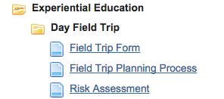

Name of proposed trip:
Faculty member name:
Educational objectives:
Date(s) of trip:
Location(s):
Grade level(s):
Number of participants:
Additional faculty attending:
Outline of proposed itinerary:
Proposed transport:
Associated costs:
Proposal for covering costs: | (e.g. student payment or particular budget…)
Class blocks students will miss:
Faculty class coverage requirements: | (please note if you have a plan in place for coverage)

Division Principal Name:

Division Principal Signature:

Date:

